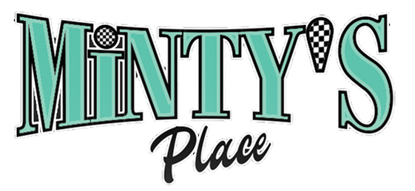
Store was originally Est. in 1930
(240) 531-1362 (Dine In, Take Out, Pickup, Reservation) CARD ONLY
Smalls Plates
Ross Jumbo Hot Dog (w Baked beans or fries) (add Beer $16.50) $ 14.95
Ms. T’s Wings (6ct) (add Fries $15.50) $ 13.50
Jamaican Jerk Beef Patty (pastry pocket w Rice) $ 13.95
Minta’s specialty Wings (10ct) w/sweet spicy sesame seed glaze $15.75
Minty’s Signature Salads
Dorchester Buttermilk Fried Chicken Salad $20.95 Our signature buttermilk fried chicken breast with on bed of fresh organic lettuce blend a delicious mix of tender greens mix greens, sweet ripe grape tomatoes, fruits apples, feta & blue cheese blend served with our signature house dressing
Chesapeake Grilled Salmon Salad $23.95 Fresh grilled Salmon on a bed of fresh organic lettuce blend, a delicious mix of tender fresh greens and spinach, sweet ripe grapevine tomatoes, and parmesan cheese blend with fresh fruits and berries and Minty’s signature house dressing
Signature Entrees
Moses Chicken and Waffles (w Skillet Mac & Cheese) $21.95 Buttermilk Fried Chicken breast w/Belgian waffle with warm syrup and powered sugar
Ross’ Smoked Grilled Pork Chop (w mashed potato w/o gravy) $23.50 Marinated smoked seasoned chop grilled to perfections ww/Minty’s signature spices
Tubman’ Spicy Shrimp Seafood Pasta $23.95 Minty’s Cajun spicy creamy butter sauce with gulf shrimp, tomatoes, peppers, onions and garlic
Minty’s Jerked Chicken (w Rice and Plantains) $20.95
Harriet’s Buttermilk Fried Chicken (smothered w rice & gravy) $20.95
Underground Railroad Fish and Grits or Gulf Jumbo Shrimp $4.00) $21.95
Araminta’s signature Fried Fish Sandwich (w Fries) $15.95
M’s Harriet’s Signature Buttermilk Fried Chicken Sandwich (w Fries) $16.95 Emancipation Cheeseburger (w French fries) $17.95

APPETIZER SIDES
Minty’s Signature Uptown Cornbread $ 5.50
Minty’s (4) cheese Mac &Cheese Skillet $ 6.50
Arminta’s Cheesy Grits $ 6.00
Field of Signature Collard Greens $ 4.50
Signature Mashed Potatoes (w or w/o gravy) $4.75
Minty’s Corn Hush Puppies (6ct) $ 4.00
Hand Cut French Fries $ 4.00
Rice with Gravy $4.50 $
Baked Beans $ 4.00
Cole Slaw $3.00
Minty’s Green Beans $ 4.00
KIDS MENU
Small Hot Dog (w/ baked beans or fries) $ 12.95
Hamburger (w baked beans or fries) (add cheese $) $ 13.25
Small Mac and Cheese $ 4.00
Grilled Cheese Sandwich (w/ baked beans or fries) $
Chicken Wings 3ct (w/ baked beans or fries) $
Belgium Waffle w/powdered sugar $4.00
Ice Cream/Skillet Desserts Cup/Cone (add scoop $3.00) $ 4.25 Cheesecake Brownie Skillet w/ice cream and toppings $ 10.75 Ms. T’s Cookie Sundae $ 9.50 Minty’s Ice cream Soda/Float $ 5.25

MINTY BEVERAGE
Coffee $2.95
Tea (sweet or unsweet) $ 2.95
Soda (Pepsi, Diet Pepsi, Starry, Pink Lemonade, Seltzer water) $ 2.95 (1 refill)
BEER SELECTIONS
Beer (Michelob Ultra, Coors Light, Stella) $ 4.00- $8.00
Heineken, Stella, $7.00
WINE SELECTIONS
White Wine:
Pinot Grigio, Chardonnay, White Zinfandel,
Bartenura Moscato D’ASTI Merlot
Red Wine:
Pinot Noir, Merlot, Menage a Trois, soft red blend, silk or dark,
Roscato Sweet Red
Woodbridge Red Blend $7.00- $12.00

Ask about our Specials!
Reservations are available for groups with at least a 20% gratuity! Please help us serve you by providing estimated number and food/drink preferences. We strive for excellence and would be happy to ensure we can provide the desired wine/beer and menu choices.
"Love thy Neighbor”

